ASSIGNMENT – 2

My App name is : Login_First_Program

App is about converting US dollar value in to other country values using API.

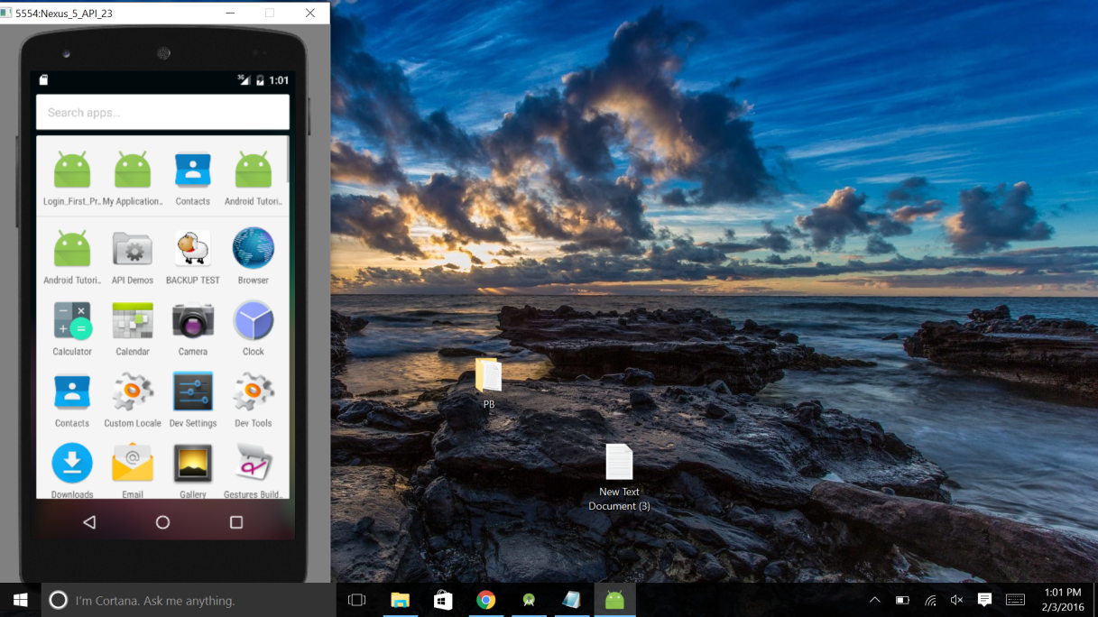

LOGIN PAGE

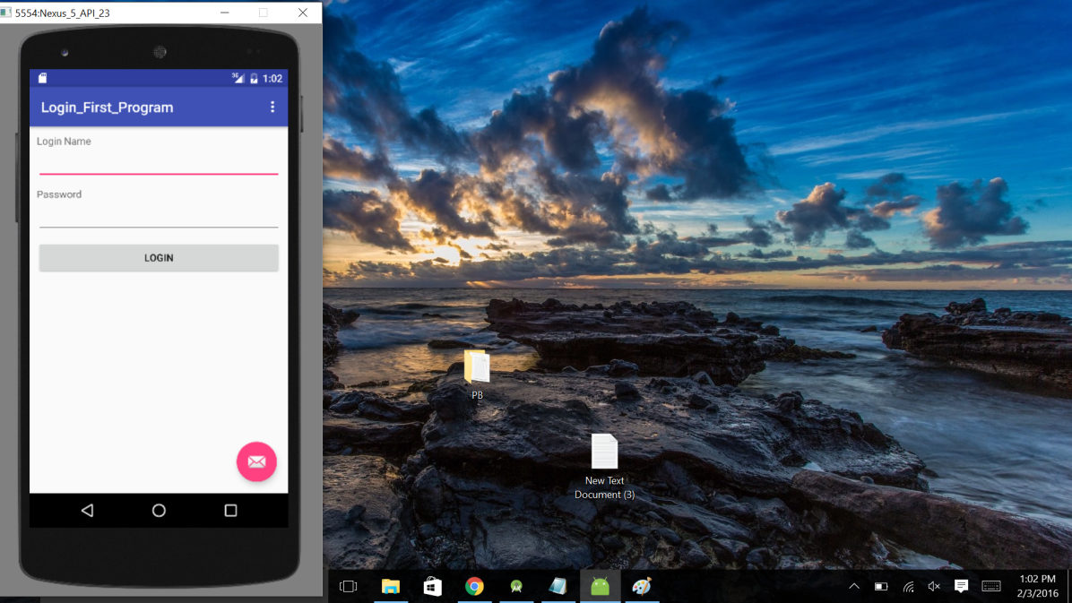

Entered incorrect values and shown wrong details popup.

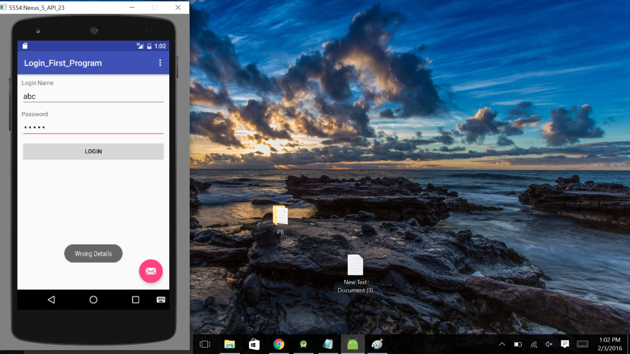

Entered correct values which are user name and password are “abc”

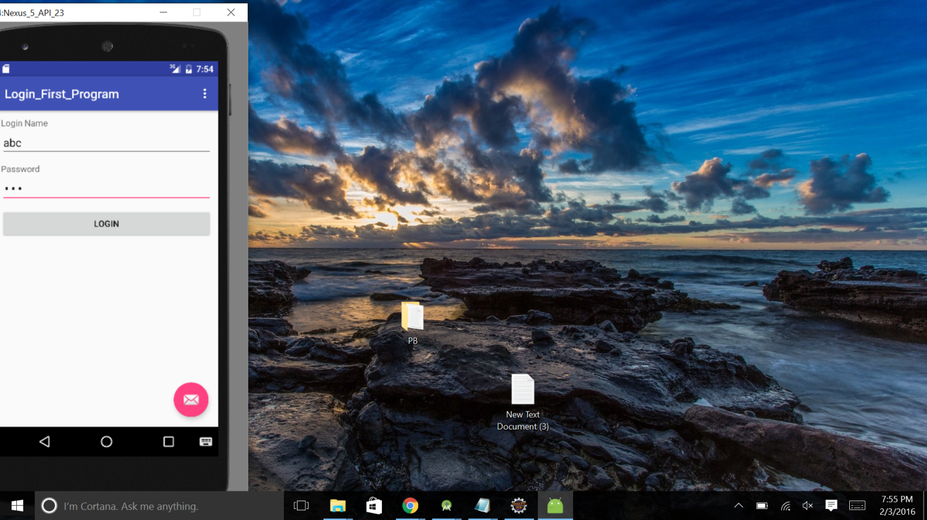

After Successful login page redirects to functional page

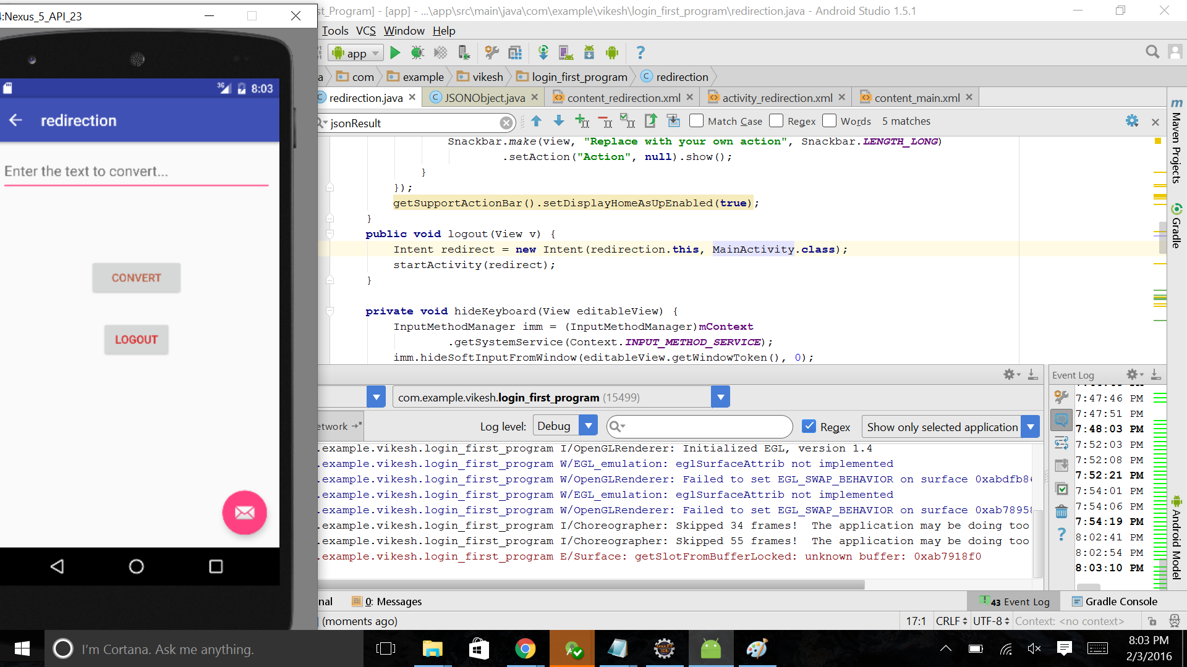

Given value in the text

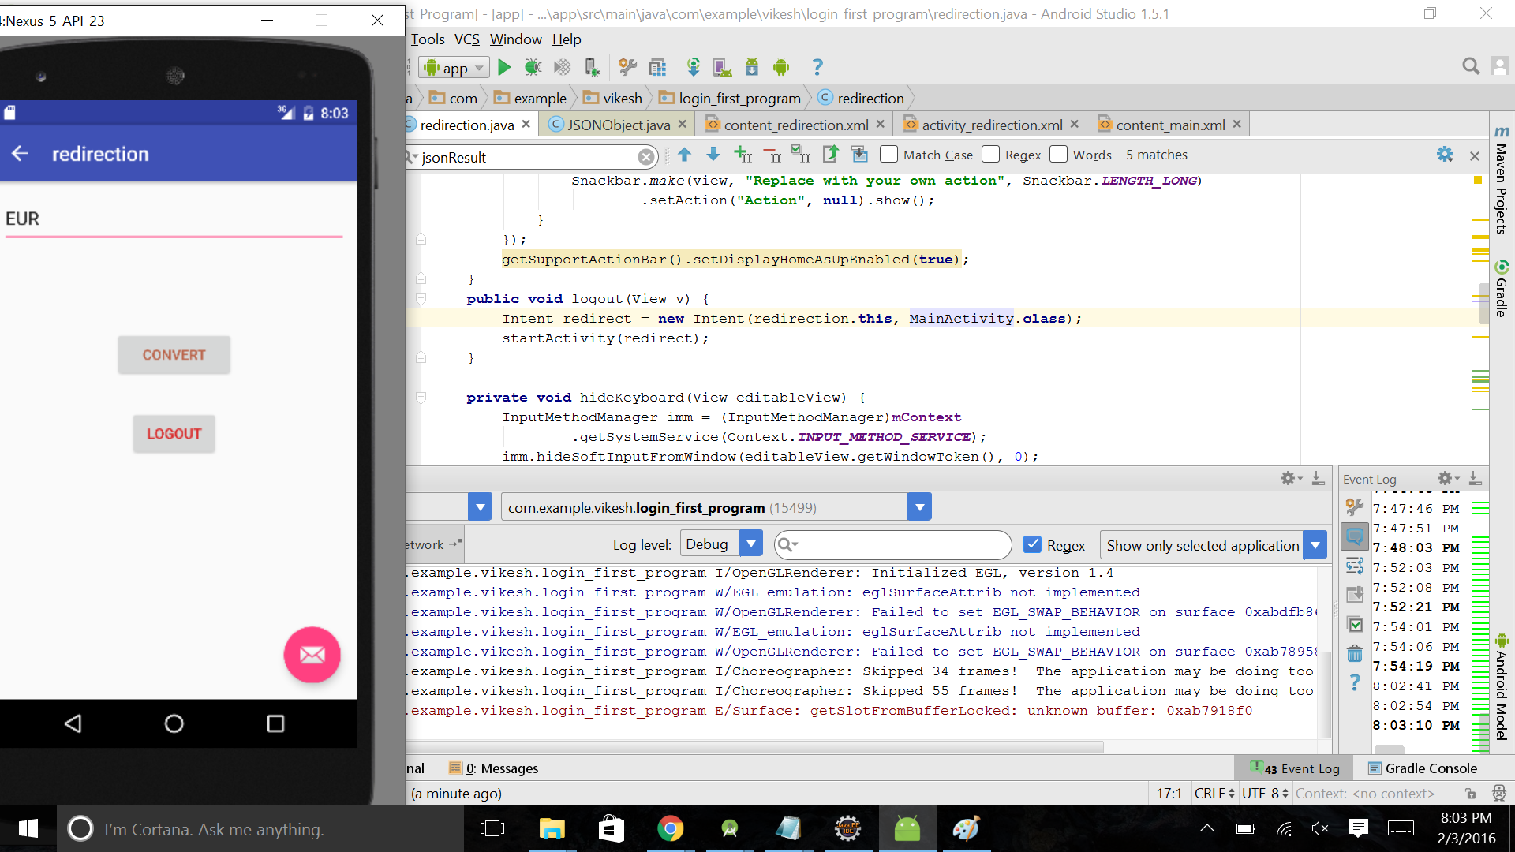

On selecting convert button output will be as shown below

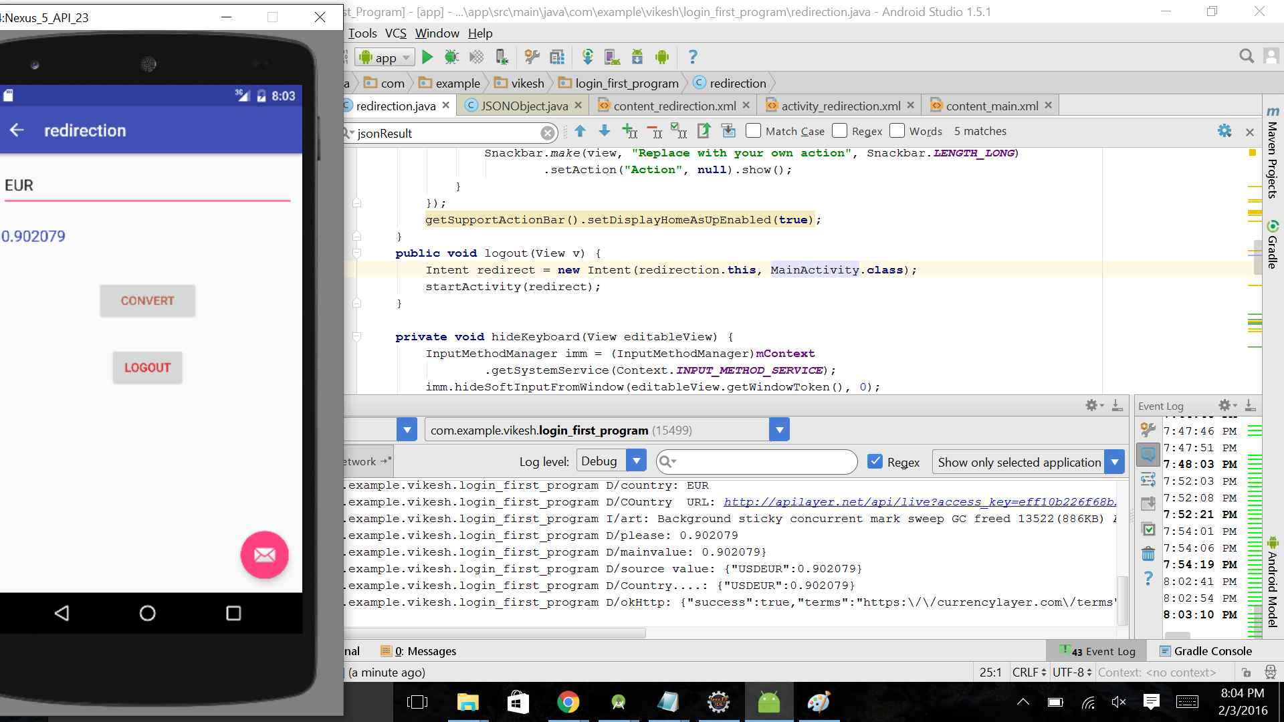

Some other examples of different countries

